

Student Name | Highlighted questions are relevant for 2017 U3 AOS 1
Teacher | GSL | HAL | LLE | MDI

Chemistry Unit 3 SAC 3
Analysis of Second hand Data Report (Concepts from AOS 2 - Ch 7.4 to 14)

Friday 5 June, 2015
Reading time: 2:05pm to 2:10pm (5 minutes)
Writing time: 2:10pm to 3:15 pm (65 minutes)

QUESTION AND ANSWER BOOK
Structure of book

Section | Number of  questions | Number of questions  to be answered | Number of  marks
A | 12 | 12 | 12
B | 5 | 5 | 49
 |  |  | Total 61

- Students are permitted to bring into the assessment session: pens, pencils, highlighters, erasers, sharpeners, rulers and one scientific calculator.
- Students are NOT permitted to bring into the assessment session: blank sheets of paper and/or white out liquid/tape.
Materials supplied
- Question and answer book of 17 pages, including answer sheet for multiple choice questions on pg 6.
- A data booklet (Please do not write in the data booklet)
Instructions
- Write your name and circle your teacher code in the space provided above on this page.
- All written responses must be in English.
- Do NOT write on the data book.
At the end of the assessment session
- Wait silently for the supervisor to collect your question and answer booklet, and your data book.

Students are NOT permitted to bring mobile phones and/or any other unauthorised electronic devices into the assessment session room.
Students must not disclose the contents of the task; to do so will be a breach of VCE guidelines and will be dealt with according to VCAA regulations.

SECTION A: Multiple-choice questions

Instructions for Section A
Answer all questions in pencil on the answer sheet provided for multiple choice questions.
Choose the response that is correct or that best answers the question.
A correct answer scores 1, an incorrect answer scores 0.
Marks will not be deducted for incorrect answers.
No marks will be given if more than one answer is completed for any question.

Use the following information to answer Questions 1–3.
When double-stranded DNA is heated slowly the individual strands separate from each other over a narrow temperature range. The midpoint temperature (Tm) of this separation is known as the melting temperature. During this transition from double helix to random coil arrangement, the absorbance at 260 nm of a particular DNA sample increases as shown in the graph below.
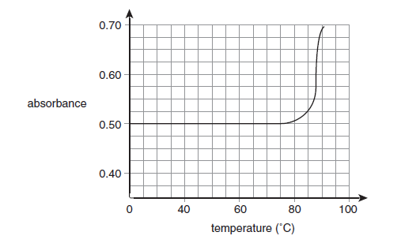

Question 1
What is the melting temperature of the DNA sample?

- 50ºC
- 73ºC
- 87ºC
- 92ºC

Question 2
Which level of structure of DNA, if any, would be disrupted during heating to determine the melting
temperature of a DNA sample?

- Primary only
- Secondary only
- Both primary and secondary
- Neither primary nor secondary

Question 3
Which of the following nitrogenous bases in the DNA sample contribute most to a high melting temperature value?
- adenine and guanine
- thymine and cytosine
- adenine and thymine
- cytosine and guanine

Question 4
The systematic name for the compound whose structure is shown below is
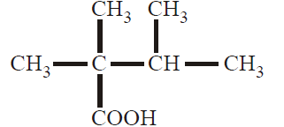
- 2,3-dimethylbutanoic acid.
- 2-methyl-2-propylpropanoic acid.
- 2,2,3-trimethylbutanoic acid.
- 2,2,3-trimethylpropanoic acid.

Question 5

The following are incomplete and unbalanced equations representing three types of chemical reactions that involve glucose. In reactions 1 and 3, product A is the same compound. In reactions 2 and 3, product B is the same compound.
reaction 1 C₆H₁₂O_{6(aq)} → C₂H₅OH_{(aq)} + product A
reaction 2 C₆H₁₂O_{6(aq)} → C₁₂H₂₂O_{11(aq)} + product B
reaction 3 C₆H₁₂O_{6(aq)} → product A + product B
Which one of the following correctly names reaction 3 and identifies product A and product B?

 | Reaction 3 | Product A | Product B
A. | Combustion | Water | Carbon dioxide
B. | Combustion | Carbon dioxide | Water
C. | Fermentation | Water | Carbon dioxide
D. | Fermentation | Carbon dioxide | Water

Question 6
A polypeptide has amino acids connected in the following ratio:
4 Glycine : | 2 Alanine : | 6 Valine
76.06 g mol⁻¹ : | 89.09 g mol⁻¹ : | 117.15 g mol⁻¹

The molar mass of the peptide would be closest to:
- 951.3 g mol⁻¹
- 969.3 g mol⁻¹
- 987.3 g mol⁻¹
- 1185.3 g mol⁻¹

Question 7
The molecule drawn below is known as metoclopramide. It is used to treat nausea and vomiting and is often used in conjunction with paracetamol.
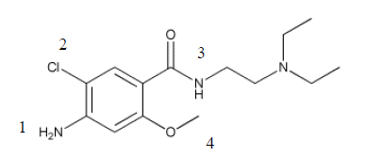
The four functional groups numbered on this molecule are, in order,
- Amine, chloro, amide and ester
- Amide, chloro, amine and ether
- Amine, chloro, amide and ether
- Amide, chloro, amine and ester

Question 8
Which one of the structures shown below is that for 1-chloro-2-methylbut-2-ene?

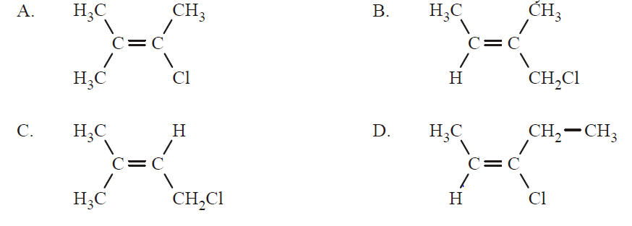
Question 9
Below is a segment of a polymer chain. Choose the monomer (s) which makes up this polymer.

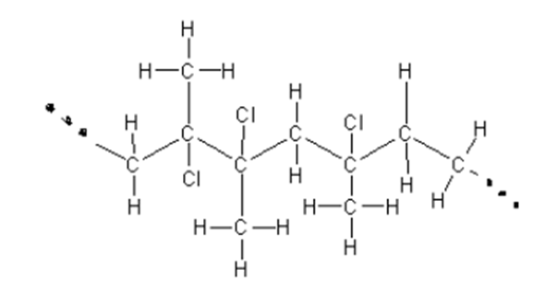

Possible monomers for this segment are:

- C(CH₃)ClC(CH₃)Cl and C(CH₃)ClCH₂
- C(CH₃)ClCH₂ only
- CH₂CH₂ and C(CH₃)ClCH₂
- C(CH₃)ClC(CH₃)Cl and CH₂CH₂

Question 10
Halothane is a general anaesthetic. The following diagram represents the reaction pathway that produces halothane.

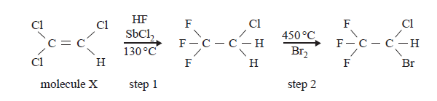

Which one of the following correctly identifies the type of reaction occurring in step 2 and correctly states the systematic name of molecule X?

 | Type of reaction in step 2 | Systematic name of molecule X
A. | substitution | 1,1,2-trichloroethene
B. | addition | 1,2,2-trichloroethene
C. | addition | 1,1,2-trichloroethene
D. | substitution | 1,2,2-trichloroethane

Question 11
Which of the following statements regarding biofuels is incorrect?

- The use of biofuels increases the overall amount of CO₂ in the atmosphere when combusted.
- The reaction that produces some biofuels is similar to the formation of triglycerides in the body in that ester linkages are created during the reaction.
- Heat, acids and bases can be used to accelerate the rate of formation of biofuels.
- The type of alkyl ester that is formed during the production of biofuel is determined by the type of alcohol used as a reactant.

Question 12
Stearic acid (C₁₈H₃₆O₂), oleic acid (C₁₈H₃₄O₂) and linoleic acid (C₁₈H₃₂O₂) are all fatty acids that can form triglycerides. When comparing the three acids it can be said that:

- Stearic acid is the most saturated fatty acid and has the lowest melting point.
- The order of melting points and degree of unsaturation increases in the following order: linoleic acid, oleic acid, stearic acid.
- Oleic acid and linoleic acid are both polyunsaturated fatty acids.
- Stearic acid is the only fatty acid that will not react with Br₂, and has the highest melting point.

End of Section A

Section A Multiple Choice Answer Sheet
This answer sheet must not be detached from this booklet.

INSTRUCTIONS FOR MULTIPLE CHOICE ANSWER SHEET
Use a PENCIL for ALL entries. For each question, shade the box which indicates your answer.
Marks will NOT be deducted for incorrect answers.
NO MARK will be given if more than one answer is completed for any question.
If you make a mistake, ERASE the incorrect answer - DO NOT cross it out.
1 |  | A |  | B |  | C |  | D
2 |  | A |  | B |  | C |  | D
3 |  | A |  | B |  | C |  | D
4 |  | A |  | B |  | C |  | D
5 |  | A |  | B |  | C |  | D
6 |  | A |  | B |  | C |  | D
7 |  | A |  | B |  | C |  | D
8 |  | A |  | B |  | C |  | D
9 |  | A |  | B |  | C |  | D
10 |  | A |  | B |  | C |  | D
11 |  | A |  | B |  | C |  | D
12 |  | A |  | B |  | C |  | D
14 |  | A |  | B |  | C |  | D
15 |  | A |  | B |  | C |  | D

SECTION B

Instructions for Section B
Answer all questions in the spaces provided. Write using black or blue pen.
To obtain full marks for your responses you should:
- Give simplified answers with an appropriate number of significant figures to all numerical questions; unsimplified answers will not be given full marks.
- Show all working in your answers to numerical questions. No marks will be given for an incorrect answer unless it is accompanied by details of the working.
- Make sure chemical equations are balanced and that the formulas for individual substances include an indication of state; for example, H_{2(g);} NaCl_{(s)}

Question 1 (11 marks)
The following graph shows the relative rate of action of two enzymes, Gastric protease and Intestinal protease versus pH.

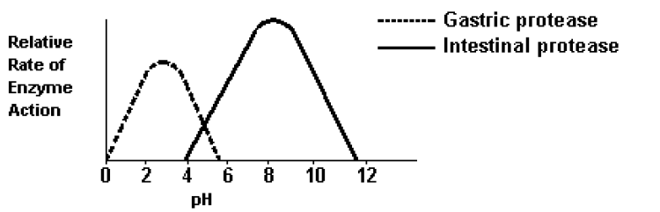

- Explain why a particular enzyme such as Gastric protease or Intestinal protease can only catalyse one specific reaction.

1 mark

- i. Use the information in the graph to determine which of the following statements provides the best possible answer when both enzymes and their substrates are mixed in a single test tube. Give an explanation why you chose this answer and not the other three options.
I Only gastric protease would be active if the pH of the mixture was basic
II Intestinal protease would be more active than gastric protease at pH 4.
III Both enzymes would exhibit some activity at pH 5.
IV Gastric protease would be more active that intestinal protease at pH 6
ii. Which of the following statements best describes the relationship between pH and enzyme action? Give an explanation why you chose this answer and not the other three options.

I All enzymes work best at a neutral pH.
II Adding more acid does not affect the rate of activity of an enzyme.
III Enzymes function only in a pH range of 4.0 to 5.5.
IV The activity of an enzyme is affected by pH.

2 + 2 = 4 marks

- A VCE student made a claim that all catalysts are solid. Explain why you agree or disagree with this claim, using a specific example that you studied this year.
1 mark

- A VCE student investigated the effect of enzyme activity on the hydrolysis reaction of proteins at different temperatures. The student’s report is provided below.
Background
Different enzymes, such as Gastric protease and Intestinal protease will increase the rate of hydrolysis reaction of proteins as the temperature increases.
Purpose
This experiment investigated the effect of using different enzymes on hydrolysis reactions of proteins at different temperatures.
Procedure
The amount of amino acids (products) was measured over time when Gastric protease was added to a volume of protein solution in a beaker at 20º C. The procedure was repeated using Intestinal protease.

Results

 | Trial 1 | Trial 2
Volume of Protein solution | 50 mL | 100 mL
Concentration of Protein solution | 1.0 M | 2.0 M
Enzyme | 10.0 g crushed Gastric Protease | 0.50 mol (solid piece) Intestinal Protease
pH of solution | 3 | 3
Amount of amino acids produced in 10 seconds | 15.0 g | 0.2

Conclusion
Gastric protease produces greater amounts of amino acids at 20º C. It is a more effective enzyme than Intestinal protease.

The student’s conclusion is not valid because the experimental design is flawed.
Critically review the student’s experimental design. In your response, you should:
- identify and explain three improvements or modifications that you would make to improve the experimental design; and
- discuss the experimental outcomes you would expect regarding the effect of temperature on enzyme activity. Justify your expectations in terms of chemical ideas you have studied this year.

5 marks

Question 2 (9 marks)
Over time, aspirin decomposes and its percentage purity decreases. To determine the percentage purity of a sample of aspirin, a VCE student followed the procedure outlined below.

A 0.2000g sample of aspirin was crushed and dissolved in 20.00mL of 0.2520 M sodium hydroxide. The equation for the reaction is:

C₉H₈O_{4(s)} + 2NaOH (aq) CH₃COONa (aq) + HOC₆H₄COONa (aq) + H₂O (l)

The solution was made up to 50.00mL and heated for 15 minutes. After heating, the volume was adjusted back to 50.00mL to compensate for any loss of solution during the heating process. 25.00mL of the solution was then titrated with 0.1056M HCl solution to find out how much NaOH was in excess. An average titre of 13.75mL was required to reach the end point.

- i. Determine the amount, in mole, of HCl used in the titration.

ii. Determine the amount, in mole, of NaOH left over in the 50.00mL solution.

iii. Determine the amount, in mole, of NaOH that reacted with the aspirin.

1 + 1 + 2 = 4 marks
- Determine the percentage purity of the aspirin sample.

3 marks

- The structure of aspirin is given below.

The active ingredient in aspirin is salicylic acid which is released after hydrolysis in the small intestine before moving into the blood stream.
Write a balanced equation showing the hydrolysis of aspirin to produce salicylic acid. Clearly show all structures (with bonds between atoms) for all reactants and products. A benzene ring may be used.

2 marks

Question 3 (11 marks)
A student was given four chemical substances labelled W, X, Y and Z and was told that they were all straight chain molecules with the following chemical formulae – not in correct order:
C₄H₁₀ C₄H₈ C₄H₁₀O C₄H₈O₂

To determine the identity of each substance from the list of molecules given, the student performed a number of experiments which are described below.

Experiment 1: Sodium carbonate solution was added to separate samples of Substance X and Substance W

 | Observations
Substance X | No bubbles of gas observed.
Substance W | Bubbles of gas observed

Experiment 2: Br₂ (aq) is added to a sample of Substance Y, and separately, to a sample of Substance Z. The change in Br₂ (aq) concentration was monitored and the following graph was obtained.
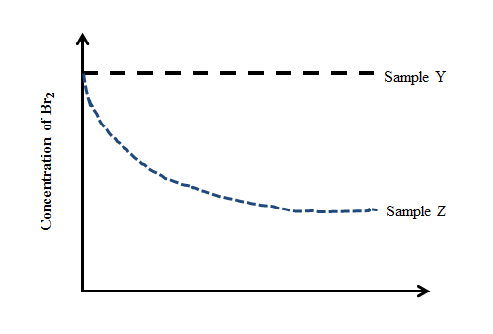
Substance Z
Substance Y
Concentration of Br₂
Experiment 3: A sample of Substance X and a sample of Substance Y were added to two separate test tubes containing deionised water.

 | Observations
Substance X | Slightly soluble
Substance Y | Not soluble

- Use the information above to draw possible structures for Samples W, X Y and Z.

Substance W | Substance X
Substance Y | Substance Z
4 marks

- Explain why the concentration of bromine decreases when it is reacted with Substance Z. In your answer, write a balanced equation to describe the reaction occurring.
2 marks

- What other conditions would be required in order to observe a decrease in the concentration of bromine when mixed with Sample Z?

1 mark

- Using semi-structural formulae show a possible reaction sequence that could be used to synthesise molecule X from an unsaturated compound.

2 marks

- Explain why alkanes and their corresponding alkenes have similar physical properties, but very different chemical properties.

2 marks

Question 4 (10 marks)
- The iodine number of a fatty acid is defined as the number of grams of iodine I₂ that reacts with 100 g of the fatty acid in an addition reaction.
- Use this value (100 g) to determine iodine number of linoleic acid. Show all workings out.

- Why does arachidic acid have an iodine number of zero?

- Write a fully balanced equation showing the complete combustion of arachidic acid. Include states.

3 + 1 + 2 = 6 marks

- A triglyceride consists of three omega-6 fatty acid molecules (C₃₄H₅₄O₂)
- How many carbon to carbon double bonds (C=C) does omega-6 fatty acid molecules have?

- What is the molecular formula of the triglyceride?

1+1 = 2 marks

- Biodiesel is manufactured from vegetable oils. This involves the reaction of the oil with an alcohol in the presence of a catalyst in a two-step process. Firstly the oil molecules are broken down into their fatty acids and one ‘other product’. The fatty acids then react with the alcohol to produce biodiesel.

- Give the name and molecular formula of the ‘other product’ as mentioned in the first step.

- Write a balanced equation for the production of the biodiesel methyl palmitoleate from its fatty acid.

1 + 1 = 2 marks

Question 5 (8 marks)
A small organic molecule has the molecular formula of the form CxHyO₂
The mass spectrum, infrared spectrum, ¹H NMR spectrum and ¹³C NMR spectrum of this compound are provided on pages 16 and 17

- On the infrared spectrum, label the peak (indicating the range) that corresponds to the presence of the functional group in this compound.
1 mark

- Use the data provided to determine the values of x and y in CxHyO₂

x = y =

2 marks

- What specific information about the structure of the compound is provided by all the splitting patterns in the ¹H NMR spectrum?

3 marks

- Draw the complete molecular structure for this molecule. Show all bonds.

1 mark
- Name the compound.

1 mark

Infrared Spectrum of C_{x}Y_{y}O₂
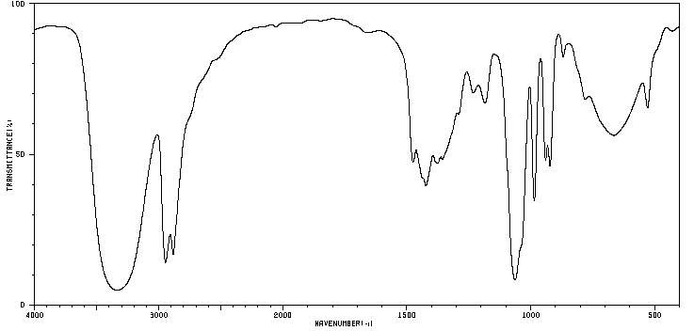
Data: National Institute of Advanced Industrial Science and Technology

¹³C NMR spectrum of C_{x}Y_{y}O₂

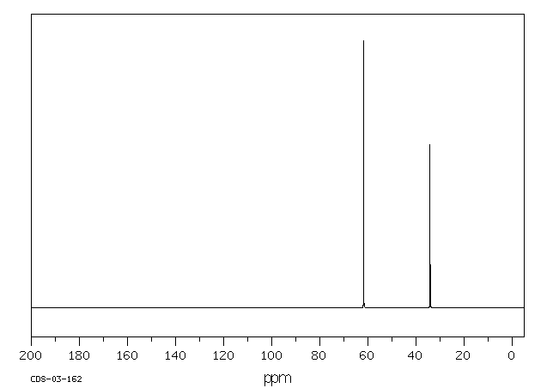
Data: National Institute of Advanced Industrial Science and Technology

Mass Spectrum of C_{x}Y_{y}O₂
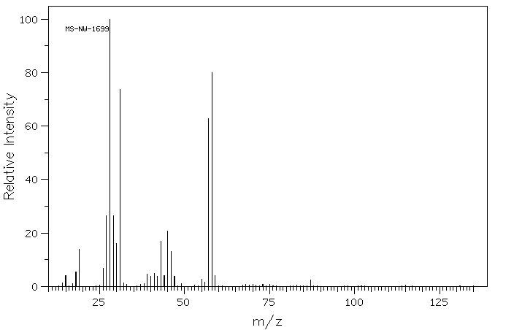

Data: National Institute of Advanced Industrial Science and Technology

¹H NMR Spectrum of C_{x}Y_{y}O₂

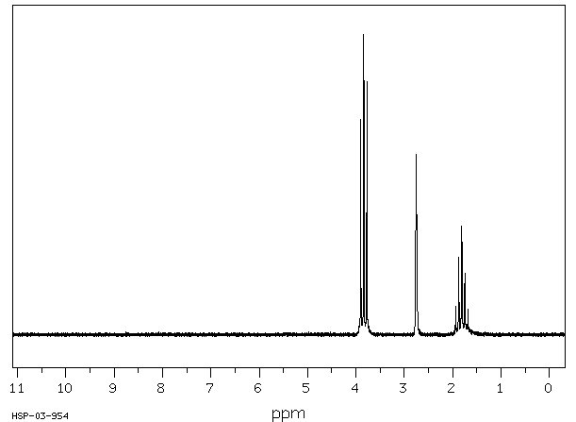
Data: National Institute of Advanced Industrial Science and Technology

¹ H NMR data

Chemical shift (ppm) | Peak splitting | Relative peak area
1.81 | Quintet | 1
2.75 | Singlet | 1
3.83 | Triplet | 2

Data: National Institute of Advanced Industrial Science and Technology

